
KR MAGALAM UNIVERSITY
ANALYSIS AND DESIGN OF ALGORITHM

DEPARTMENT - SOET

COURSE CODE - ENCS256
NAME – SAKSHI SINGH
ROLL NUMBER-2401420042
COUSRSE-B TECH CSE DATA SCIENCE

Task 1: Algorithm Growth Observation Write Python programs to implement the following functions:
1. Constant Time : O(1)
2. Linear Time : O(n) 3.
Quadratic Time : O(n2)
4. Logarithmic Time : O(log n)
Steps
• Measure execution time for different input sizes (e.g., n = 10, 100, 500, 1000).
• Plot Input Size vs Execution Time.
• Observe and comment on the growth pattern.
Deliverables
• Python script or notebook
• Execution time plots Task 2: Best, Average, and Worst Case A
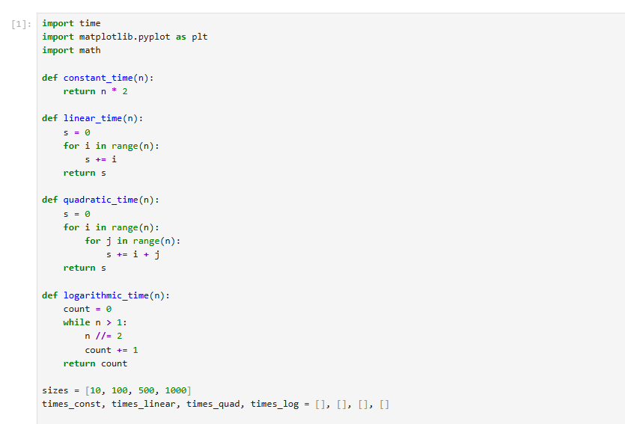
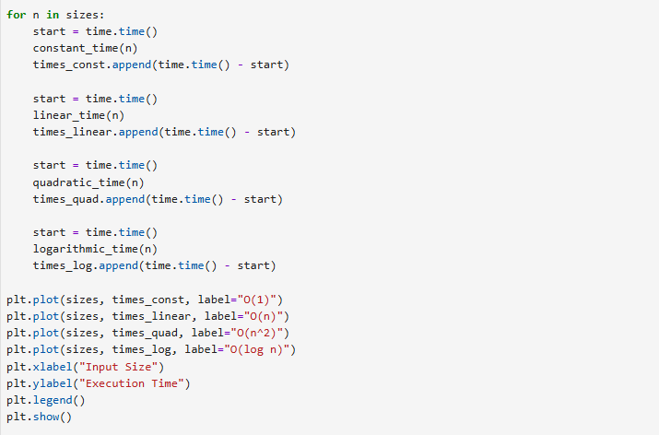
Output:
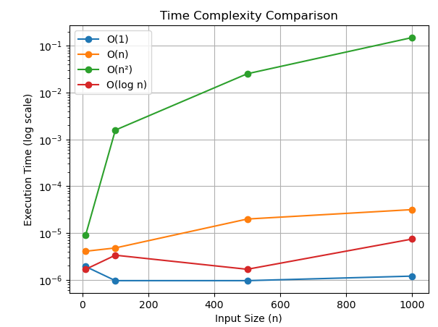

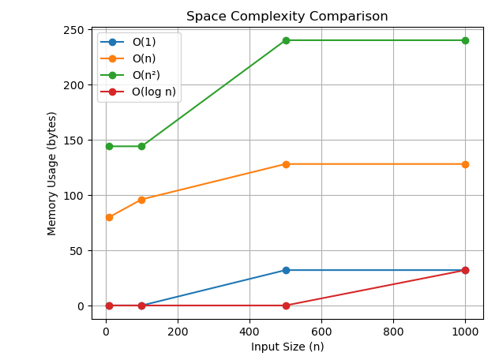

Task 2: Best, Average, and Worst Case Analysis
Implement Linear Search and Binary Search.
Requirements
• Generate random arrays of different sizes.
• Measure execution time for: o Best case o Average case o Worst case
• Compare results using plots.
Deliverables
• Search algorithm implementations
• Comparison plots
• Observations in comments/markdown
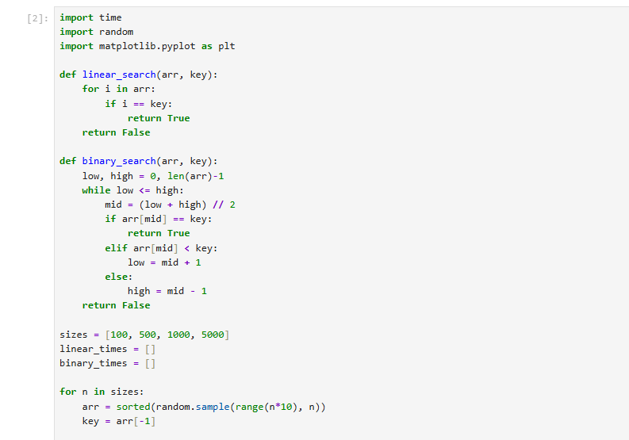
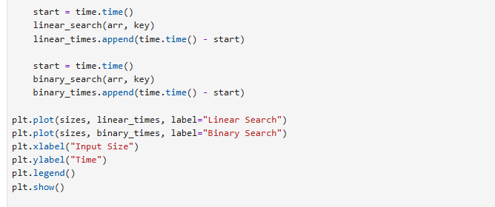
Output:
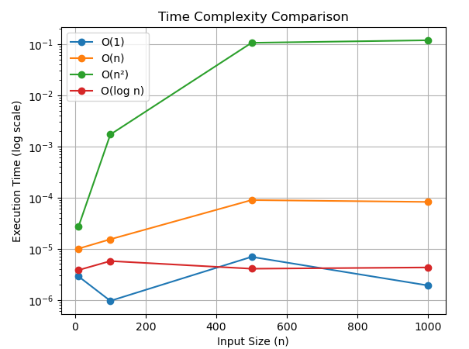
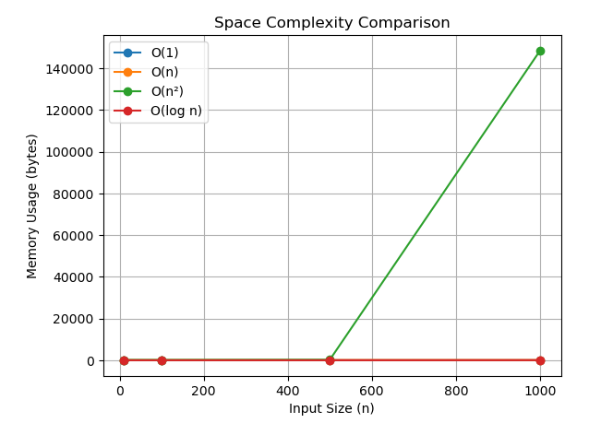
Task 3:
Recursion and Recurrence Validation
Implement the following recursive algorithms:
1. Factorial
2. Fibonacci (Naïve Recursive)
3. Fibonacci (Dynamic Programming)
Steps
• Count number of function calls for each input size.
• Measure execution time.
• Compare recursive vs optimized approach.
Deliverables :
• Python implementations
• Table comparing execution time and function calls
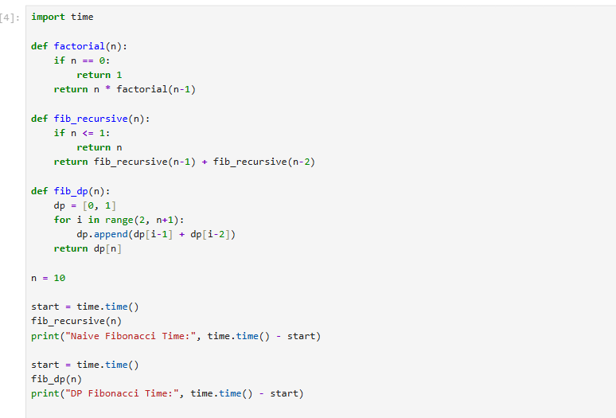
Output:
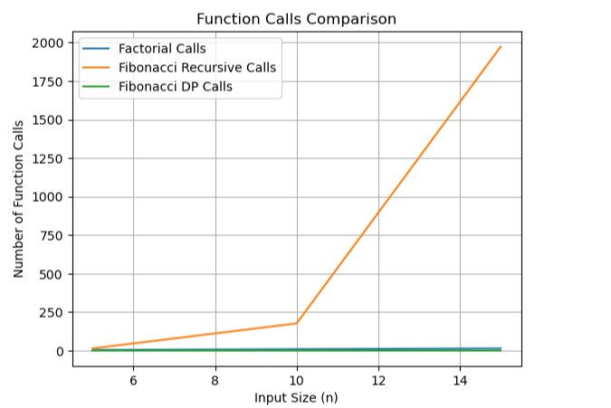
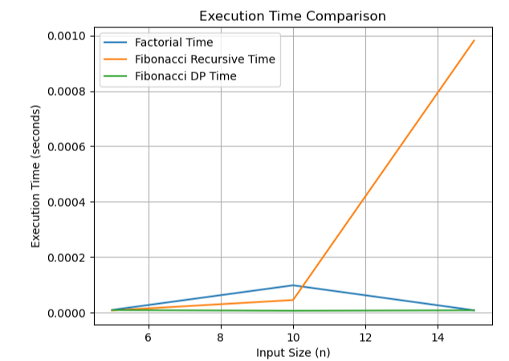

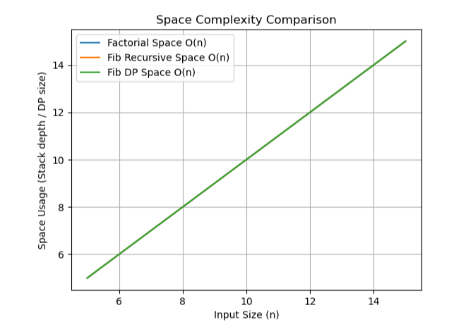

Task 4:
Solving Recurrences through Code
Implement recursive functions corresponding to these recurrences:
1. T(n) = T(n/2) + n
2. T(n) = 2T(n/2) + n
Steps
• Count recursive calls.
• Measure execution time.
• Validate results with expected asymptotic complexity.
Deliverables
• Code with call counters
• Observational comments
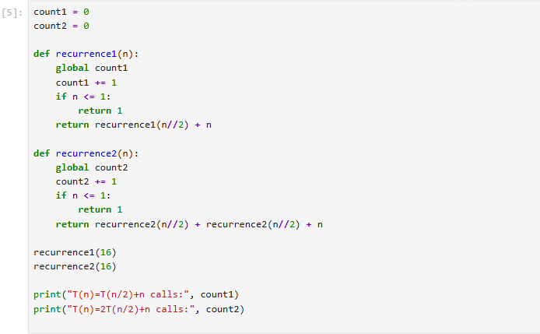
Output:
